
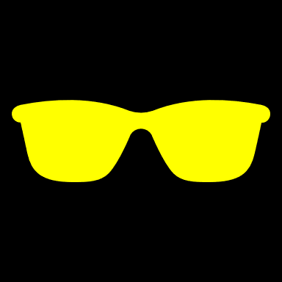




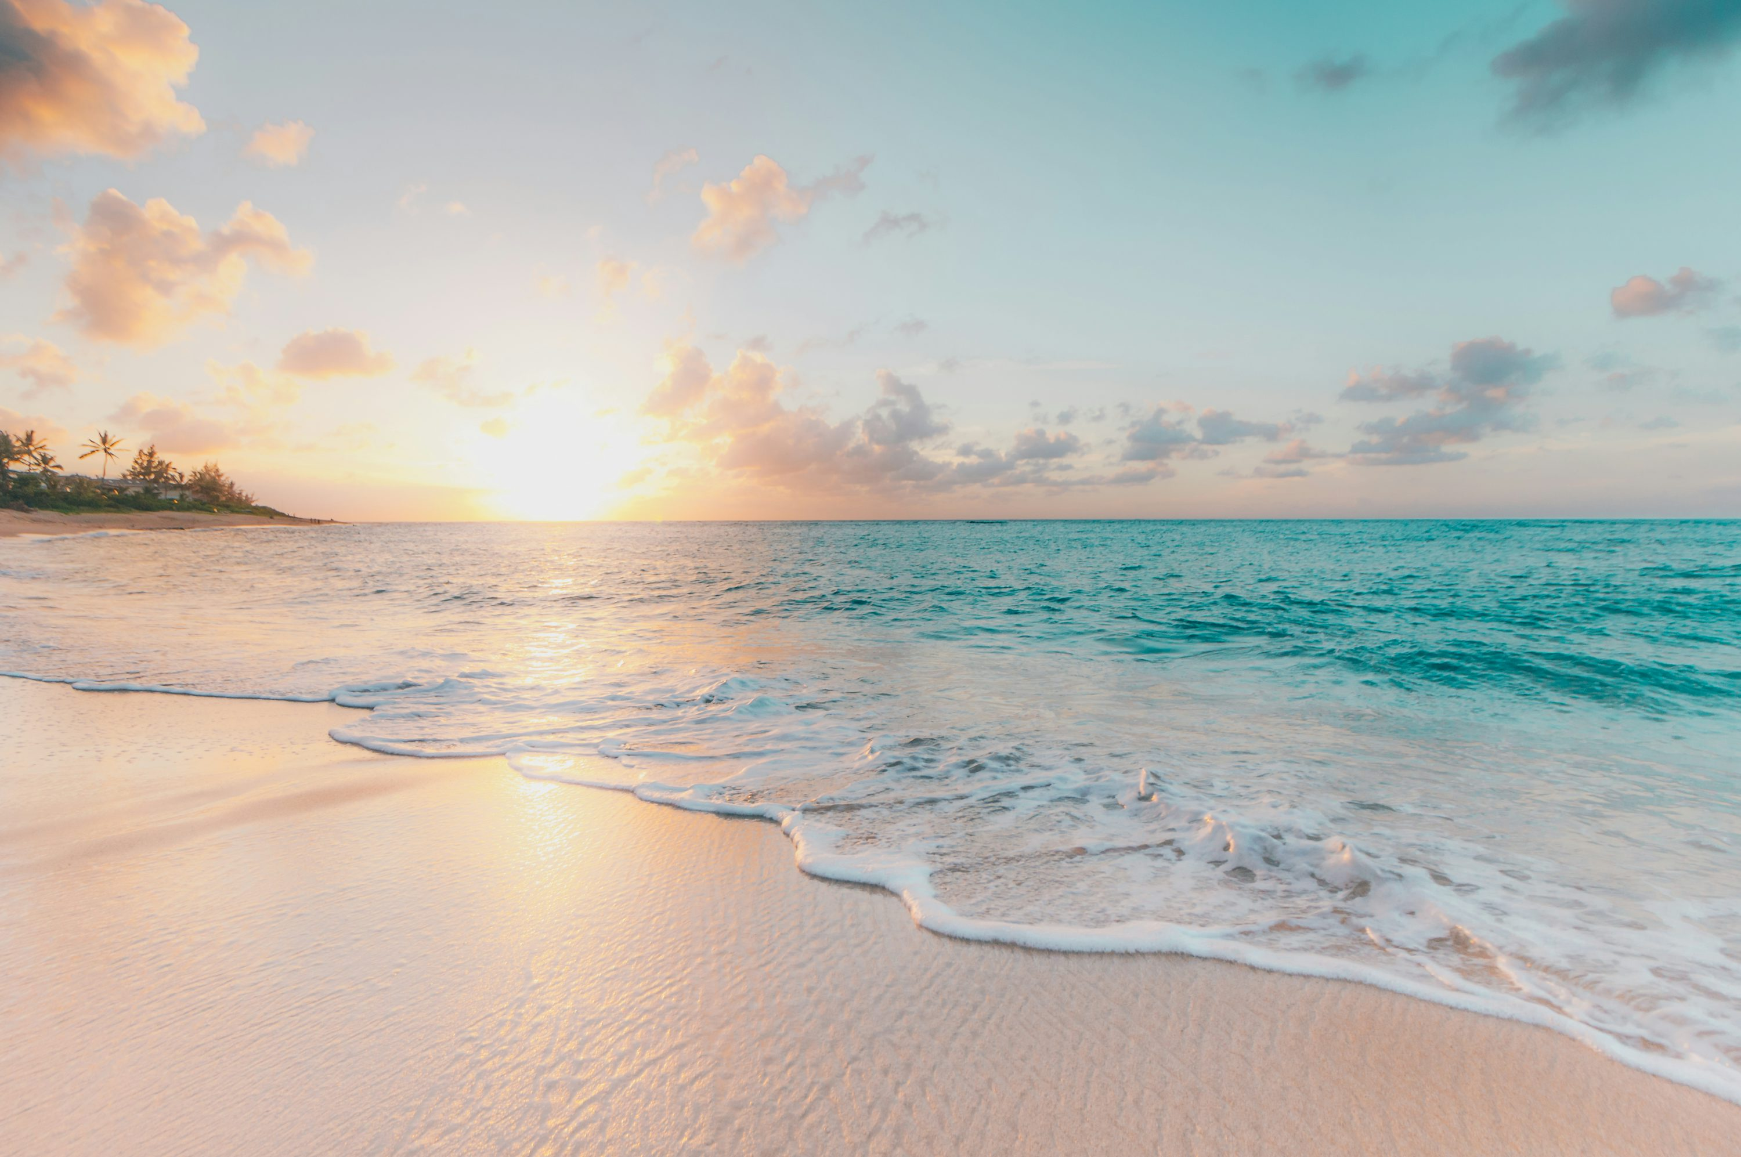









V
- Go to a hill station to escape the heat
- Go camping under the stars
- Try water sports/swimming
- Go for hiking or nature walks
- Visit a nearby botanical garden
- Go to a beach and collect seashells
- Explore local forests or trails
- Plan a picnic in a park
- Go fishing
- Take a weekend road trip to a new town
- Make hibiscus jewelry holders from clay
- Craft handmade flower hair clips
- Design custom aesthetic shell candles
- Make seashell necklaces
- Design summer-themed nail art
- Learn to play a new instrument
- Paint scenery or learn watercolor painting
- Make a DIY summer sticker book
- Make homemade lemonade from scratch
- Roast marshmallows for s'mores
- Pick fresh berries or peaches at a local farm
- Try baking a fruit pie
- Make homemade ice cream or fruit popsicles
- Visit a local food festival
- Make your own iced coffee blends
- Do science experiments at home
- Participate in a general knowledge quiz
- Read five new books over the summer
- Start a small, personal blog or journal
- Repair your sleep schedule and build a routine
- Attend a summer workshop or online course

HOLIDAY CHECK’S LIST

